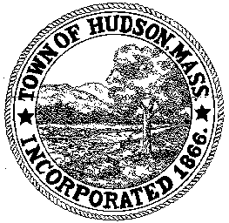

BOARD OF HEALTH
78 Main Street
Hudson, MA 01749
(978) 562-2020
Meeting Agenda
April 10, 2012
7:00 PM

- Preliminaries
1.1 Open Meeting
1.2 Roll Call

2.0 General Business
2.1 Transfer Station

2.2 Update on Grant 2.3 Minutes March 29, 2012

3.0 Site Plan Reviews
3.1 81 High Street

3.2 70 Felton Street

4.0 Voucher BOH 041012

5.0 Adjournment

Next Meeting April 24, 2012

